**------------------------------------------------------------------------------------**

**Name – Pawar Shrikant Sanjeev**

**SE IT**

**Roll No.47**

**CG Lab**

**Assignment No.4 : Brehensem Line**

**------------------------------------------------------------------------------------**

**------------------------------------------------------------------------------------**

**#include<GL/freeglut.h>**

**#include<stdlib.h>**

**#include<iostream>**

**using namespace std;**

**float x1,x2,y1,y2;**

**int ch;**

**void draw_pixel(int x, int y){**

**glBegin(GL_POINTS);**

**glVertex2i(x, y);**

**glEnd();**

**}**

**void draw_vertex(){**

**glBegin(GL_LINES);//show axes**

**glVertex2f(200.0f, 0.0f);**

**glVertex2f(-200.0f, 0.0f);**

**glVertex2f(0.0f, -200.0f);**

**glVertex2f(0.0f, 200.0f);**

**glEnd();**

**}**

**void display(void)**

**{**

**int m_new = 2 * (y2 - y1);**

**int slope_error_new = m_new - (x2 - x1);**

**//draw_pixel(x,y);**

**draw_vertex();**

**for(int x = x1, y = y1 ; x <= x2 ; x++){**

**switch(ch){**

**case 1 :**

**draw_pixel(x, y);**

**break;**

**case 2 :**

**if((int) x % 2 == 0)**

**draw_pixel(x,y);**

**break;**

**case 3 :**

**if((int) x % 7 < 4)**

**draw_pixel(x,y);**

**break;**

**case 4 :**

**if((int) x % 10 < 5 || (int) x % 10 == 7)**

**draw_pixel(x, y);**

**break;**

**}**

**slope_error_new += m_new;**

**if (slope_error_new >= 0)**

**{**

**y++;**

**slope_error_new -= 2 * (x2 - x1);**

**}**

**}**

**glFlush();**

**}**

**void init(void)**

**{**

**glClearColor(0.7,0.7,0.7,0.7);**

**gluOrtho2D(-200,200,-200,200);**

**}**

**int main(int argc, char** argv)**

**{**

**cout<<"Enter the value of x1 : ";**

**cin>>x1;**

**cout<<"Enter the value of y1 : ";**

**cin>>y1;**

**cout<<"Enter the value of x2 : ";**

**cin>>x2;**

**cout<<"Enter the value of y2 : ";**

**cin>>y2;**

**cout<<"\n\n MENU";**

**glutInit(&argc, argv);**

**glutInitDisplayMode (GLUT_SINGLE | GLUT_RGB);**

**glutInitWindowSize (500, 500);**

**glutInitWindowPosition (100,100);**

**do**

**{**

**cout<<"\n 1 : Solid";**

**cout<<"\n 2 : Dotted";**

**cout<<"\n 3 : Dash";**

**cout<<"\n 4 : Dash-Dottd";**

**cout<<"\n 5 : Exit";**

**cout<<"\n\n Enter your choice : ";**

**cin >> ch;**

**if(ch >= 5)**

**cout<<"\n thank u....";**

**else**

**{**

**glutCreateWindow ("Bresenhams Line Drawing Algorithm");**

**init();**

**glutDisplayFunc(display);**

**glutMainLoop();**

**}**

**cout<<"\n ch : "<<ch;**

**}while(ch < 5);**

**return 0;**

**}**

**------------------------------------------------------------------------------------**

**Output**

**------------------------------------------------------------------------------------**

**Enter the value of x1 : -100**

**Enter the value of y1 : -95**

**Enter the value of x2 : 85**

**Enter the value of y2 : 75**

**MENU**

**1 : Solid**

**2 : Dotted**

**3 : Dash**

**4 : Dash-Dottd**

**5 : Exit**

**Enter your choice : 1**

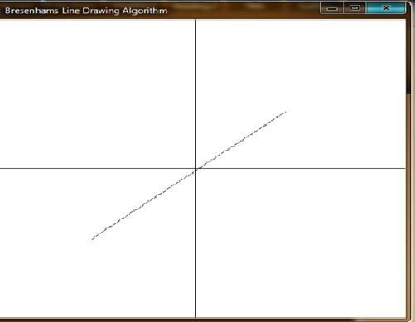

**Enter the value of x1 : -110**

**Enter the value of y1 : -80**

**Enter the value of x2 : 98**

**Enter the value of y2 : 80**

**MENU**

**1 : Solid**

**2 : Dotted**

**3 : Dash**

**4 : Dash-Dottd**

**5 : Exit**

**Enter your choice : 2**

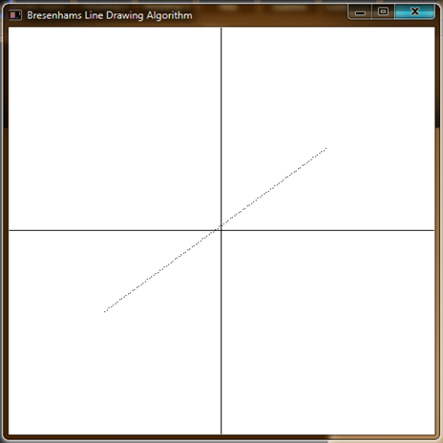

**Enter the value of x1 : 10**

**Enter the value of y1 : 20**

**Enter the value of x2 : 100**

**Enter the value of y2 : 110**

**MENU**

**1 : Solid**

**2 : Dotted**

**3 : Dash**

**4 : Dash-Dottd**

**5 : Exit**

**Enter your choice : 3**

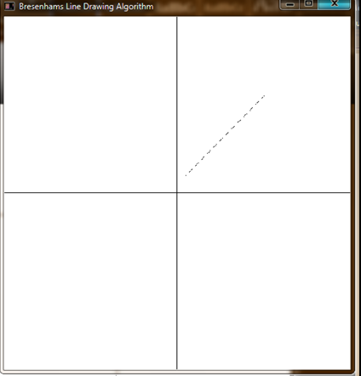

**Enter the value of x1 : 5**

**Enter the value of y1 : -10**

**Enter the value of x2 : 110**

**Enter the value of y2 : 120**

**MENU**

**1 : Solid**

**2 : Dotted**

**3 : Dash**

**4 : Dash-Dottd**

**5 : Exit**

**Enter your choice : 4**

